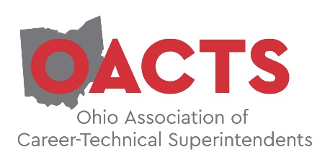

Agenda
OACTS Issues Forum
Friday, April 17, 2020
Medallion Club

8:00 am Registration, Coffee and Conversation

8:30 am Welcome and Introductions – Greg Edinger, OACTS President

8:45 am Relationships with Legislators – Terrence O’Donnell,

9:00am The Value and Importance of Customized Training for your OTC – Tony Huffman, Washington County
Lauren Massie, Pickaway-Ross and Carrie Fife, C-TEC

9:45am ODE Updates: Leah Amstutz, Director, Office of CTE

10:30am Remarks by Representative Don Jones, Chair House Education Committee, District 95

11:00am Sector Partnerships: Making an Impact – Shawn Hendrix, President, Nissen Chemitec America

11:30am The Third Frontier

12:15pm Lunch
Legislative Update and CTE Funding Discussion - Will Vorys

Special Thanks to our Sponsor:

